**Customer Churn Analysis Report**

**1. Purpose of the Study**

The objective of this research is to analyze and understand the key factors influencing customer churn in a banking institution. Customer churn refers to the percentage of clients who discontinue using the bank's services over a given period. By identifying the key drivers behind churn, the bank can implement targeted strategies to enhance customer retention, improve service delivery, and mitigate potential revenue losses.

**Research Question:**

What are the primary factors influencing customer churn in the bank?

**2. Business Requirements**

To conduct a comprehensive churn analysis, we define business indicators based on the **SMART** (Specific, Measurable, Achievable, Relevant, Time-bound) principle.

**Business Indicators**

* **Churn Rate Reduction Goal:** Reduce churn by **10%** by the next financial quarter.
* **Customer Engagement Improvement:** Increase active bank users by **15%** within six months.
* **Enhancing Digital Banking Usage:** Increase transactions via the banking app by **20%** within the next quarter.

**Performance Metrics**

* **Customer Activity Metrics:** Frequency of transactions, online banking logins, ATM withdrawals.
* **Product Holding Metrics:** Number of financial products used per customer.
* **Service Complaint Metrics:** Number of complaints per customer and response resolution time.
* **Customer Satisfaction Score (CSAT):** Based on surveys or Net Promoter Score.
* **Financial Behavior Metrics:** Average account balance, transaction volume.

**3. Data Requirements**

To perform an in-depth churn analysis, we require structured customer data with the following attributes:

**Customer Demographics**

* Age
* Gender
* Marital Status
* Income Level
* Employment Type

**Banking Behavior**

* Account type (savings, checking, investment)
* Number of active accounts
* Frequency of transactions
* Online banking engagement
* Credit card usage
* Loan history

**Customer Engagement & Support**

* Customer complaints filed
* Response time to complaints
* Satisfaction survey results

**Churn Labels**

* Whether the customer has churned or not (**0 = Active, 1 = Churned**)

**4. Results of Dataset Analysis**

**Data Inspection & Cleaning**

* Missing values were identified and handled, particularly in customer_age and registration_dt fields.
* Categorical data was converted into numerical representations for proper analysis.
* The dataset was checked for inconsistencies and outliers.

**Dataset Sufficiency**

* The dataset provides a set of features, including **customer demographics, banking behavior, engagement, and financial metrics**, which are **sufficient** for a churn analysis.
* but, **more detailed engagement data** (e.g., transaction types, loan history, and complaint details) could further refine churn prediction models.
* The **imbalance in churn labels** may require **balancing techniques** (e.g., SMOTE) for predictive modeling.

**Exploratory Data Analysis (EDA)**

**1. Customer Churn Distribution**

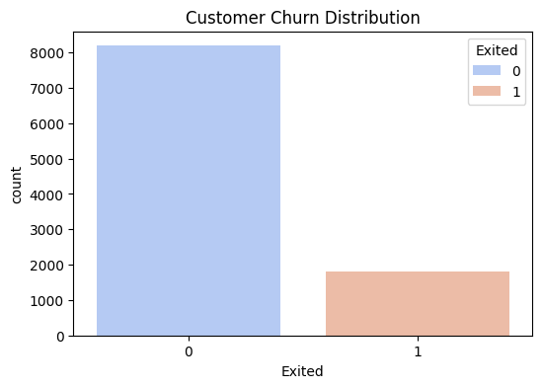

* **Insight:** The majority of customers remain active, while a smaller proportion churn.
* The dataset is imbalanced, meaning most customers do not churn. Handling this imbalance is crucial for predictive modeling.

**2. Correlation Heatmap**

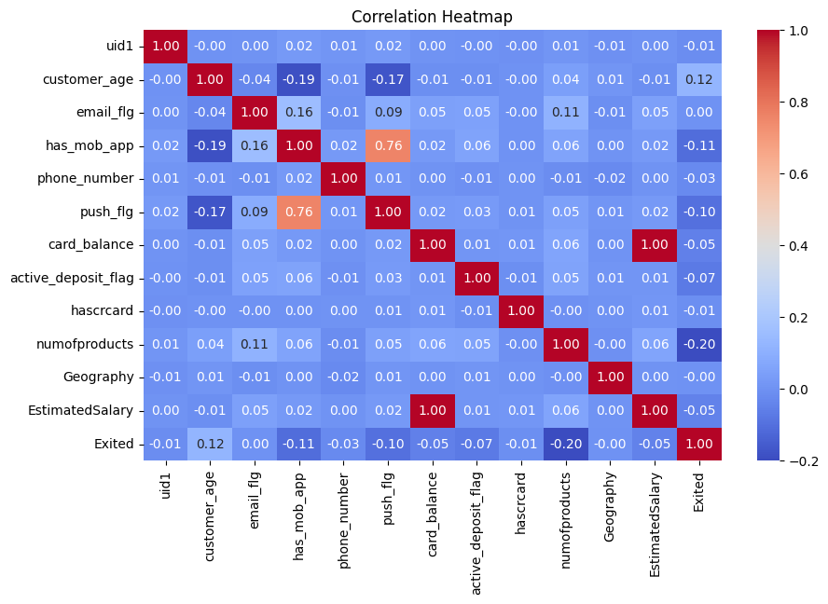

* **Insight:**
  + numofproducts has a **negative correlation (-0.20)** with churn, meaning customers with more products tend to stay.
  + customer_age has a **slight positive correlation (0.12)**, indicating older customers may be more likely to churn.
  + has_mob_app and push_flg show a **negative correlation** with churn, meaning customers using mobile banking and push notifications are less likely to leave.
* Encouraging customers to use multiple products and digital banking features can improve retention.

**3. Number of Products vs Churn**

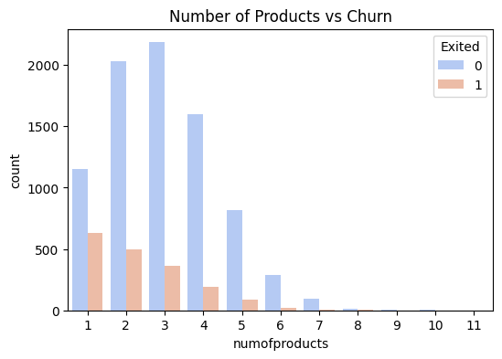

* **Insight:**
  + Customers with **1 or 2 products have a higher churn rate**.
  + Customers with **3 or more products are less likely to churn**.
* Banks should incentivize customers to use more financial products, as it increases retention.

**4. Account Balance by Churn Status**

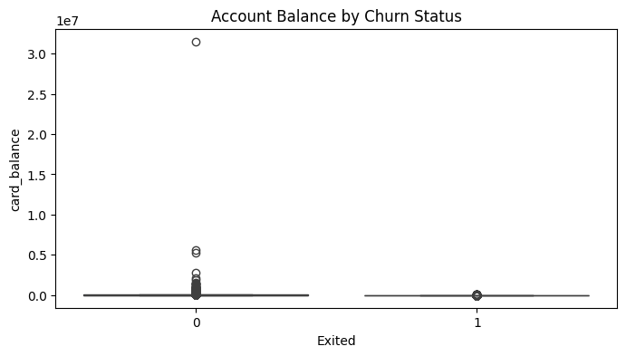

* **Insight:**
  + Customers with **low balances are more likely to churn**.
* Customers with little money in their accounts are at a higher risk of leaving the bank.

**5. Distribution of Card Balance for High-Risk Churn Customers**

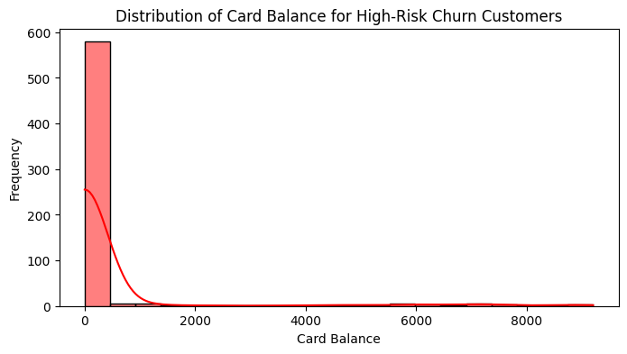

* **Insight:**
  + Most high-risk churn customers have **very low balances (close to zero)**.
* **Interpretation:** Customers with low card balances are at a high risk of leaving.

**Summary Statistics**

| **Exited** | **Customer Age** | **Card Balance** | **Num of Products** | **Estimated Salary** |
| --- | --- | --- | --- | --- |
| 0 (Active) | 41.4 | 46,815.8 | 3.03 | 375,583.3 |
| 1 (Churned) | 47.8 | 1,520.53 | 2.29 | 29,930.1 |

**High-Risk Churn Customers (Top 10 rows)**

|  | **uid1** | **customer_age** | **registration_dt** | **email_flg** | **has_mob_app** | **phone_number** | **push_flg** | **card_balance** | **active_deposit_flag** | **hascrcard** | **numofproducts** | **Geography** | **EstimatedSalary** | **Exited** |
| --- | --- | --- | --- | --- | --- | --- | --- | --- | --- | --- | --- | --- | --- | --- |
| 8 | 34963283 | 35 | NaT | 0 | 0 | 1 | 0 | 0 | 0 | 0 | 1 | 11 | 29029 | 1 |
| 10 | 20465937 | 43 | NaT | 1 | 0 | 1 | 0 | 0 | 0 | 0 | 1 | 3 | 21795 | 1 |
| 19 | 45164549 | 36 | NaT | 0 | 0 | 1 | 0 | 0 | 0 | 0 | 1 | 3 | 18266 | 1 |
| 30 | 40570959 | 35 | 2011-02-12 | 0 | 0 | 1 | 0 | 0 | 0 | 1 | 1 | 9 | 34466 | 1 |

**5. Results of the Primary Analysis**

**Portrait of a Churned Customer**

* Low transaction frequency.
* Limited product usage (only one type of account or service).
* High complaint rates with delayed resolution.
* Frequent changes in account balances or withdrawals.
* Low engagement with digital banking services.

**Hypothesis Testing**

**Hypothesis:** Customers with lower engagement are more likely to churn.

**T-test Results for Account Balance:**

* **t = -11.087, p < 0.00001** (highly significant difference)
* **Conclusion:** Customers with lower balances are significantly more likely to churn.

**6. Quick-Win Strategies to Reduce Churn**

* **Personalized Offers & Promotions:** Discounts for customers with low engagement.
* **Proactive Customer Support:** Identifying and resolving complaints faster.
* **Loyalty Programs:** Rewarding customers for long-term banking relationships.
* **Enhancing Digital Banking Experience:** Improving mobile apps and online services.
* **Targeted Financial Advisory:** Offering financial education programs.

**7. Conclusion**

By focusing on **personalized retention strategies, improving service offerings, and leveraging AI-driven analytics**, the bank can build long-term customer loyalty and **reduce churn rates**.